**IRAffinity FTIR Mirror Lock-Down Procedure and Storage**

The IRAffinity-1S spectrometer has a research-grade interferometer optic system with a moving mirror. It is important to follow a lock-down procedure for the mirror before removal or transfer of the instrument from the laboratory bench installation position. Also, the beamsplitter employed in the optical configuration is hydroscopic and can be damaged by moisture absorption. The instrument is designed to be left plugged into the mains power supply at all times. Before moving the instrument, please follow the procedures below and then re-establish the instrument power supply:

**Mirror Lock-Down Procedure**

Firstly, turn off the FTIR spectrometer using the front switch on the instrument.  Then unplug the instrument from the mains power supply and remover the USB interface cable.  Remove any accessories from the sample compartment.

Take the cover off by loosening the two screws on the left and right side of the FTIR (no need to unscrew completely) using a Philips cross-head screwdriver.  The cover lifts off vertically.  Make sure the screw washers are left at the head of the screw so that the cover will fit behind them during replacement.

Next, locate a 3mm Allen-Key fitting which would normally be available in a socket set (e.g. from Maplins).

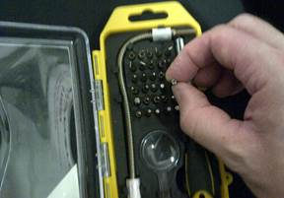

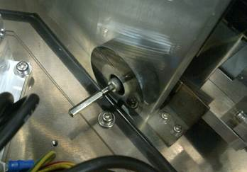

Take the 3mm hex-key fitting from the tool case. Note: it is a good idea to have at hand a magnetic retrieval tool which is useful should any tools be dropped into the instrument.

The 3mm hex-key will fit into the hex-nut at the left-back side of the mirror encasement.  Be sure not to place excessive force against the surrounding optical components when trying to insert the hex-key, as this may put the alignment of components at risk.  Make sure to note that locating the hex-key during the reverse unlock procedure will be slightly more difficult as the bolt will be recessed and you will not be able to view it properly.

Turn the hex-nut clockwise until it stops (do not over-tighten).  Then turn back for one turn.

This will ensure that the moving mirror is not distorted under clamped tension, yet is prevented from excessive movement during transport.

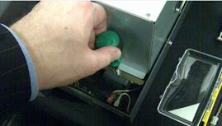

There are two further lock-down screws for the base movement (the base is isolated from the case to prevent vibrations).  The first is at the front-right corner.

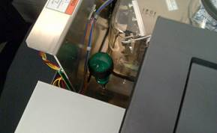

The second one is at the front-left corner of the optic casing.

Lastly, put back the cover and secure the four side screws in place. The instrument can be safely transported to another location.  Please ensure that there are no sudden jolts applied to the spectrometer and locate the instrument in a suitable position in accordance with the User Manual supplied with the system. Once the instrument is relocated, plug the instrument into the mains socket and turn on at the wall – it is important to do this as the instrument contains an electronic drying system to protect the KBr beamsplitter. The KBr beamsplitter is susceptible to damage by moisture ingression.

The installation and re-commissioning procedure would be a reverse procedure of the above instructions.  Please be aware that electrical components will be exposed to the user and the electricity supply must be removed from the instrument whilst work of this nature is carried out.  Shimadzu will not be held liable for any consequences of carrying out this procedure or related work.  All work will be at the customer’s own risk.  A qualified electrically trained representative for the customer company must be present to advise/assist with the process according to company health and safety regulations.

Note: If the instrument is to be left in storage for a long period of time and power cannot be maintained to the instrument, then the electronic membrane device that removes moisture will not be operative, thereby putting the KBr beamsplitter at risk. There are packets of desiccant present in the instrument housing, which will remove a fixed level of moisture but they will not indefinitely protect the system (they are included as a safeguard should there be a laboratory power cut). Under these circumstances, and once the mirror has been locked down, it is advisable to purchase a large amount of desiccant placed in a ventilated container within the instrument sample compartment. Then completely wrap the IRAffinity instrument in an air-tight high-density polythene bag, sealed against any air ingression. This should protect the beamsplitter and optical components until it is removed and connected again to the mains power supply. A sealable bag for this purpose can be purchased from any hardware store (e.g. Argos <https://www.argos.co.uk/sd/jumbo-vacuum-bags/> ) that will enable a vacuum to be placed against the sealed port.